**LinkedIn**

The use of this API is restricted to those developers approved by LinkedIn and subject to applicable data restrictions in their agreements.

**Usage**

You may only store data returned from the Profile API for the authenticated members with their permission. Please refer to this document for guidance on storing authenticated member data. You may never store data returned from the Profile API for members other than the authenticated member.

**Retrieve Current Member's Profile**

**Permissions**

This API requires one of the following permissions:

Permission Description

r_liteprofile Required to retrieve name and photo for the authenticated user. Please review Lite Profile Fields.

r_basicprofile Required to retrieve name, photo, headline, and vanity name for the authenticated user. Please review Basic Profile Fields. Note that the v2 r_basicprofile permission grants only a subset of fields provided in v1.

Request

To identify and retrieve the current member's profile based on the access token, simply call:



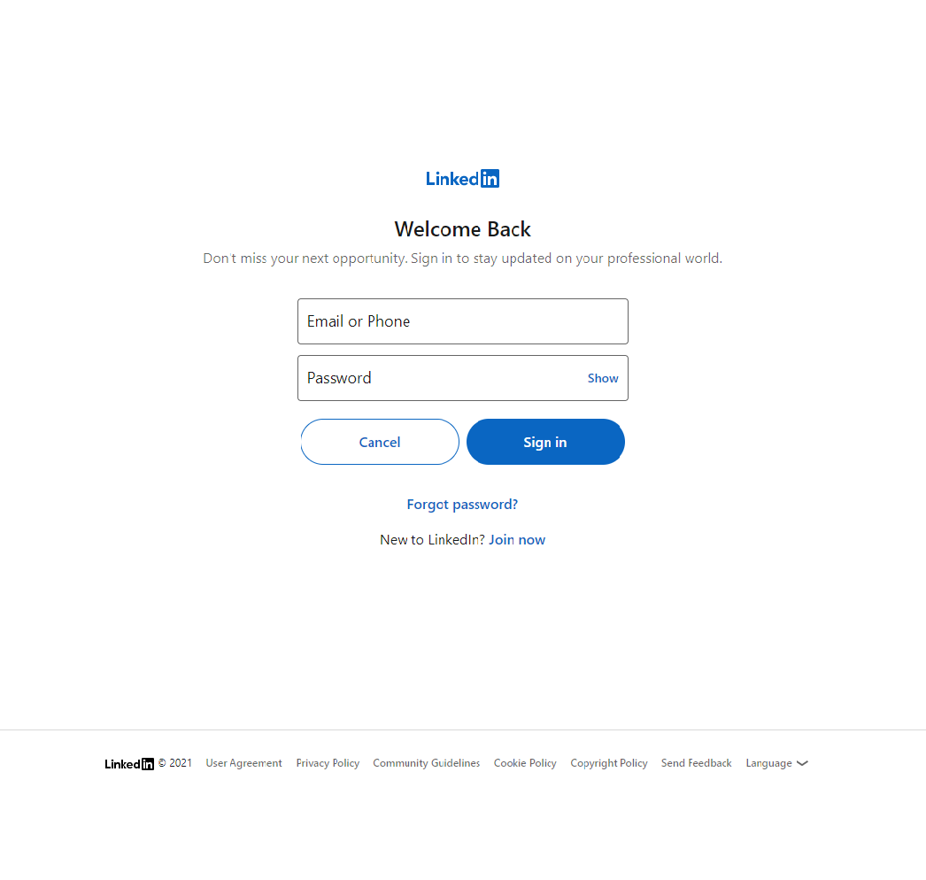

**Google map**

The Maps JavaScript API lets you customize maps with your own content and imagery for display on web pages and mobile devices. The Maps JavaScript API features four basic map types (roadmap, satellite, hybrid, and terrain) which you can modify using layers and styles, controls and events, and various services and libraries.

This documentation is designed for people familiar with [JavaScript](http://www.ecma-international.org/publications/standards/Ecma-262.htm) programming and object-oriented programming concepts

The following example displays a map.

.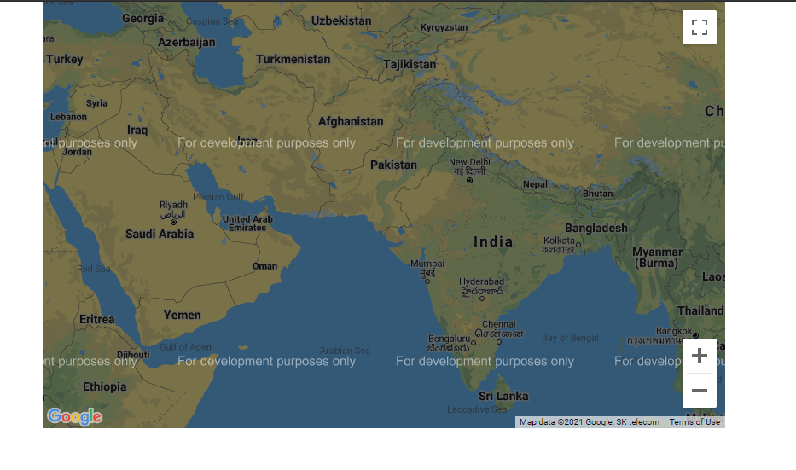

**Time and weather**

Open weather API is one of the most recognizable and elegant APIs. Powered by ML technologies, it provides all necessary for businesses weather information for any location on the globe

